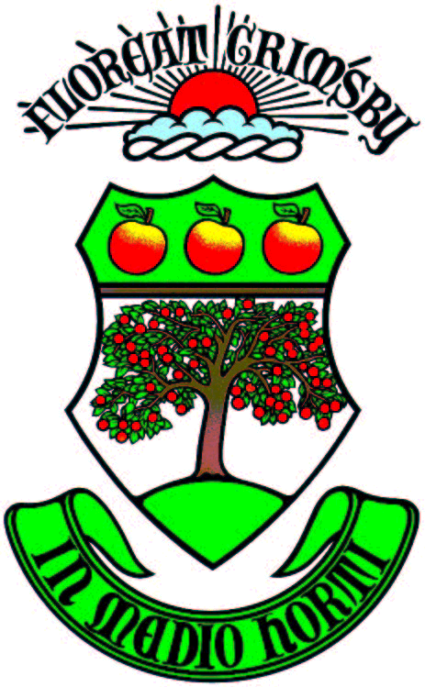 NOTICE OF INTENTION TO DESIGNATE
266 Main Street West

TAKE NOTICE that Grimsby Town Council, on June 5th, 2023 resolved to issue a Notice of Intention to Designate PT LT 13 CON 2, North Grimsby (FMLY PCL 3); PT 3, 30R-9825 ; GRIMSBY as a property of cultural heritage value or interest under Part IV of the Ontario Heritage Act.
The Reason for the Notice of Intention to Designate is to recognize the physical, associative and contextual value that 266 Main Street West contributes towards the Town of Grimsby’s inclusive heritage.
Statement of Cultural Heritage Value or Interest
When this house was built in 1902, Edwardian Classical design was only starting to gain popularity. Historic dwellings at this time featured clean lines and lighter colours than those of the Victorian period. Interestingly, the addition of electric lights meant that lighter colours were in style due the lack of soot traditionally found in homes during this time.
Notably, the decorative elements of this Edwardian home features strong influence from the Queen Anne architectural style with aesthetic flairs and additions, which is in keeping with the vernacular style traditionally found along the historic Main Street West corridor. The exterior of 266 Main Street West is a good representation of the Queen Anne style of decoration, which can be seen in the large porch/verandah, the ornate details of the fretwork, the fish-scale shingles, clapboard combinations, and the dormers in various locations.
The dwelling at 266 Main Street West shows a high degree of artistic merit and craftsmanship that is traditionally found within Queen Anne architecture and contains many elements of the Edwardian architectural style. The shingle and clapboard have a lot of detail and character, and the gingerbread style trim around the porch and the small arched windows add character to the building. The symmetry of the dormer windows add artistic meet to the historic dwelling.
The historical value of the building at 266 Main Street West connects back to the early foundations of the Village of Grimsby. In the early 20th century, this house was owned by a prominent medical doctor in the town who lived there until 1926. Dr. Wolfenden was a Grimsby resident for sixteen years, and was the senior house physician at the London Hospital and was also the resident physician for the late Emperor Frederick of Germany. He retired in 1890 and came to Grimsby in 1910 as a fruit grower. This property was farmed during the height of the fruit farming industry within the Town of Grimsby and contributes directly to the success and prosperity of the town.
Earlier historical value traces the property of 266 Main Street West to the roots of the Nixon family, and specifically Dennis Nixon in c.1877-1885. The land registry records are not clear on who owned the property before hand, but the Historical Atlas of Lincoln and Welland, illustrated 1876 show the land belonging to the Nixon family.
The dwelling at 266 Main Street West contributes to the scale, mass and form of historic dwellings that lined the historic Main Street West corridor during the height of the fruit farming industry. The dwelling enhances the unique character along the historic corridor and contributes to the style of dwellings that was traditionally found along this corridor. The location of the house on Main Street West provides insight into the agricultural development in Grimsby along the Main Street corridor, historically positioned close together allowing farms to extend back towards the lake. The prosperity of the fruit industry led to higher quality and varying styles of nineteenth and early twentieth century homes – including Queen Anne Revival style houses. The dwelling at 266 Main Street West contributes to an understanding of the Queen Anne style of architecture that was so prominent for fruit farmers in the late 19th century.
The character of Main Street West is comprised of various Queen Anne and Edwardian style homes and are a testament to the prosperous fruit farming industry that the Garden of Canada experienced in the 1890s-1920s. Before the Great War Period and the Great Depression, the Town of Grimsby had a large influx of industry and fruit farming that helped define its historical character.
The house at 266 Main Street West is visually linked to its surroundings as it contributes to the historical character of Main Street West. The King’s Highway (Main Street West) was once a very prominent route, before the Queen Elizabeth Way. This corridor contains large estates that visually illustrate the prosperity of the community at the time of the dwellings construction.
HERITAGE ATTRIBUTES TO BE DESIGNATED

The Heritage Attributes to be designated at 266 Main Street West include:

- Edwardian Architectural Design with Queen Anne Architectural Style Elements
- Flat Top Roof
- Secondary Addition
- Ornate Fretwork on Porches
- Dormers
- Arched Window Openings
- Original Window Openings
- Wooden Windows
- Original Door Openings
- Shutters
- Fish Scale Shingles
- Ionic Porch columns
- Cedar Shake siding
- Clap board siding
- Brick chimney
- Symmetrical front façade
- Setback from Main Street

OBJECTIONS
Any objection to this designation must be filed no later than 30 days after the date of publication of the notice of intention in a newspaper. Objections should be directed to Bonnie Nistico-Dunk, Town Clerk, Town Clerk, 160 Livingston Avenue, Grimsby ON, L3M 0J53.
MORE INFORMATION
Any inquiries may be directed to Bianca Verrecchia, Heritage Planner at 905-945-9634 ext. 2122 or by email bverrecchia@grimsby.ca
Last date to file Notice of Objection: November 18th, 2023

